** East West University**

**Course No: CSE109 Lab**

**Experiment Number:** 04

**Experiment Name:** Verification of Thevenis's Theorem

**Date of Experiment: 20/10/2016**

**Date of submission: 27/10/2016**

**Group: 5**

**ID: 2016-1-60-053**

**2016-1-60-057**

**2016-1-60-058**

**2016-1-60-060**

**Experiment Number:** 04

**Experiment Name:** Verification of Thevenis's Theorem.

**1. Objectives:** The objectives of this experiment is to verify Thevenis's Theorem using laboratory experiment.

**2. Equipment / Apparatus:**

(i) DC Voltage Source (01)

(ii) Decade resistance box (01)

(iii) Resistors (R1= 1.5 k, R2= 1.5 k, R3= 0.47 k, RL= 1K )

(iv) Multi-meter (01)

(v) Ammeter(01)

(vi) Breadboard

(vii) Wires

**3. Experimental Setup:**

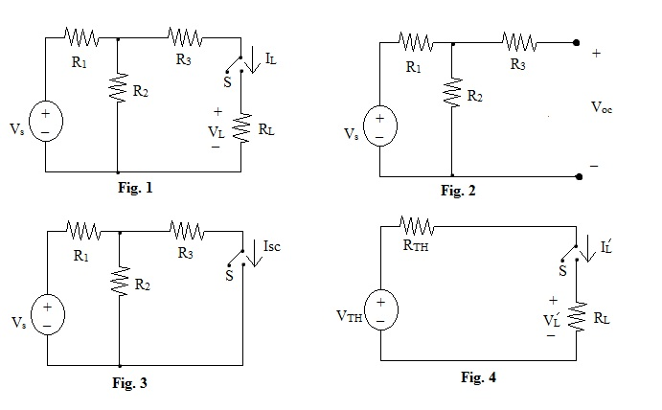

**4. Procedure:**

(i) Measure the resistance of the resistors **R1**, **R2**, **R3** and **RL** by using the multi-meter.

(ii) Connect the circuit as shown in **Fig. 1** in breadboard.

(iii) Turn on the DC voltage source and measure it's voltage **Vs** by using the multi-meter. Adjust the voltage changing KNOBs of the voltage source such that the output voltage becomes **I5 V**.

(iv) Connect the ammeter across switch **S**, open the switch **S** and measure current **IL** by using the ammeter. Close the switch **S**.

(v) Measure the voltage **VL** across the resistor **RL** by using multi-meter.

(vi) Open **RL** from the circuit shown in **Fig. 2** and set **VS** = 15V by measuring voltage using multi-meter.

(vii) Measure the open circuit voltage **VOC** by using the multi-meter.

(viii) Short the two open terminals be a switch **S** to create the circuit shown in **Fig. 3** and set **Vs** =15 V by measuring voltage using the multi-meter.

(ix) Open the switch **S** and measure the short circuit current **ISC** by usingtheammeter.

(x) Calculate **VTH** and **RTH** in data table with **VTH** = **VOC** and **RTH =VOC / ISC**.

(xi) Set the resistance of the decade resistance box equal to **RTH**.

(xii) Connect the circuit as shown in **Fig. 4**. Use decade resistance box for **RTH**.

(xiii) Set the output voltage of the DC voltage source equal to **VTH** by measuring voltage using multi-meter.

(xiv) Connect the ammeter across switch **S**, open the switch **S** and measure current **I'L** by using the ammeter. Close the switch **S.**

(xv) Measure voltage **V'L** across the resistor **RL**  by using the multi-meter.

(xvi) Perform the calculations below.

**5. Data Table:**

|  |  |  |  |  |  |  |  |  |  |  |  |  |
| --- | --- | --- | --- | --- | --- | --- | --- | --- | --- | --- | --- | --- |
| R1 (K) | R2 (K) | R3 (K) | RL (K) | Vs (V) | VL (V) | IL (mA) | VOC (V) | ISC (mA) | VTH (V) | RTH (K) | V'L (V) | I'L (mA) |
| 1.45 | 1.42 | 0.47 | 0.99 | 15 | 3.49 | 3.33 | 7.48 | 5.8 | 7.48 | 1.29 | 3.39 | 3.29 |

**6. Calculation:**

(i) 100 * (VL - V'L) / VL  = 100* (3.49 - 3.39) / 3.49 = 2.86

(ii) 100 * (IL - I'L) / IL = 100 * (3.33 - 3.29) / 3.33 = 1.2

**7. Questions & Answers:**

(i) Do the experiment results verify the Thevenis's Theorem ? Why are you getting some discrepancies ?

**Answer:** From Thevenis's Theorem we know,

"Any two-terminal, linear bilateral dc network can be replaced by an equivalent circuit consisting of a voltage source and a series resistor."

Before replace with Thevenis's equivalent circuit we have, R1= 1.45 k, R2= 1.42, R3= 0.47 k and we measure VOC = 7.48, IL = 3.33, ISC = 5.8, VL = 3.49.

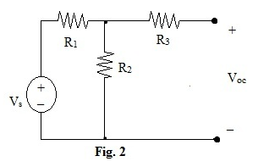

After replacing the circuit with an equivalent Thevenis's circuit,

RTH = 7.48/5.8 = 1.29

VTH = VOC = 7.48

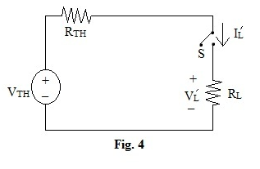

The we got ,

V'L = 3.39

I'L = 3.29

So, we got little difference after replacing the circuit with an equivalent Thevenis's circuit and it verifies the Thevenis's Theorem.

We got some discrepancies because of ammeter, which is measuring very low current of circuit and also for the environment.

(ii) Theoretically determine VL and IL by series-parallel operation / mesh analysis / nodal analysis?

**Answer:** Here,

RT = 2.169

I = 15 / 2.169 = 6.912

IL = 6.912 * (1.42 || 1.47) / 1.46 = 3.409

VL= 3.409 * 1.46 = 4.9

(iii) Theoretically determine VTH and RTH and then draw the Thevenis's equivalent circuit?

**Answer:** Here,

ISC = 5.8

VOC = (R2 * VS) /( R1 + R2) = (1.42 * 15) / (1.45 + 1.42)

= 7.42

VTH = VOC = 7.42

RTH =VOC / ISC  = 7.42/5.8 = 1.27

Thevenis's equivalent circuit:

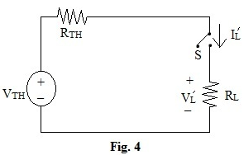

**8. Discussion:**

(i) For measuring current we have to use the exact value of ammeter Errors less than 10-3 will be ignored.

(ii) Measuring the resistance of resistors we have to remember that human hand can effect on the value of resistance. We have to avoid them.

(iii) When calculating data we should be very careful for approximate values.